**Assignment 17.5**

**Problem Statement:**

Write a map reduce program to design a custom counter to count number of people are affected with 'PULMONARY' disease and 'BRONCHITIS & ASTHMA' in the state 'CA'.

**Input:**

You can download the dataset from the below link:

<https://drive.google.com/file/d/0ByJLBTmJojjzeUV3RV81TU5oLUk/>

**Program:**

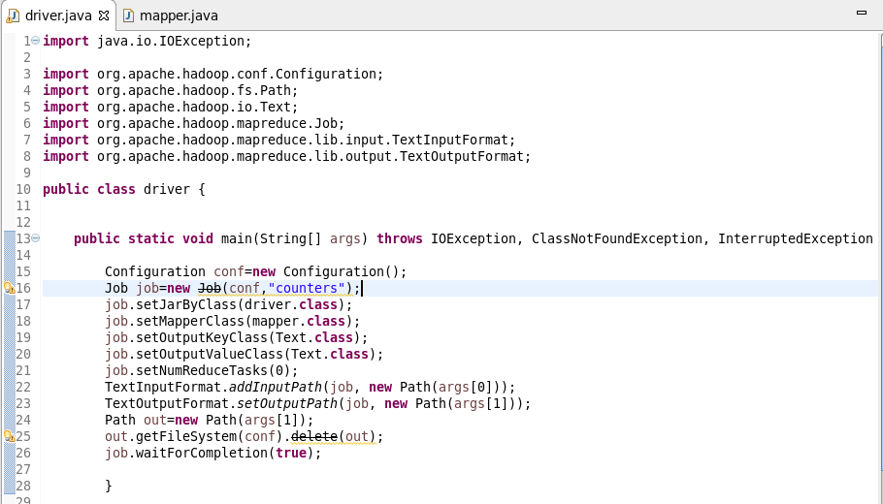

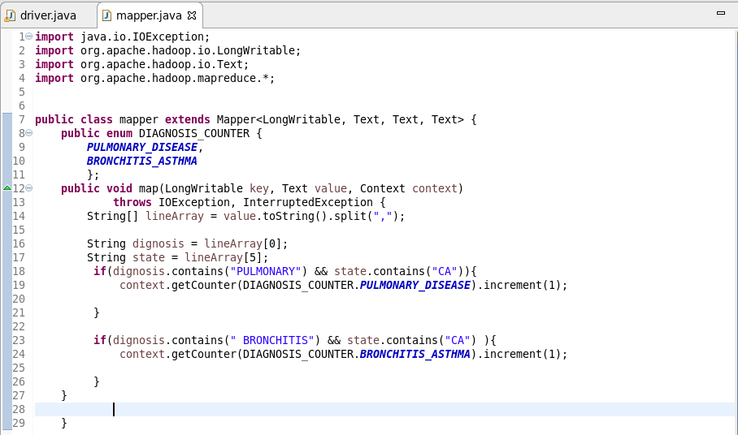

**Output:**

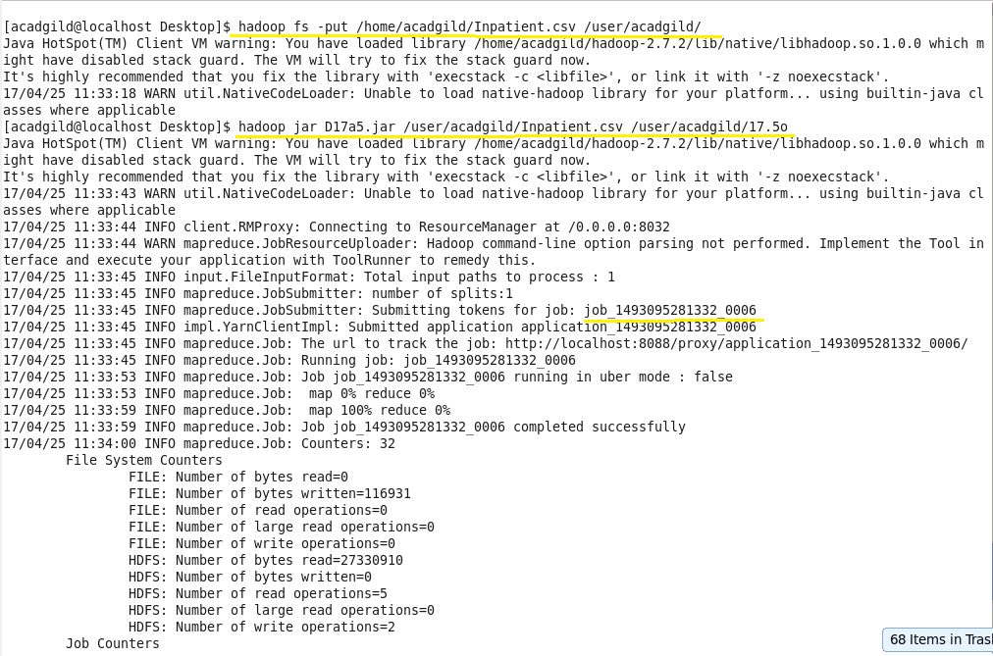

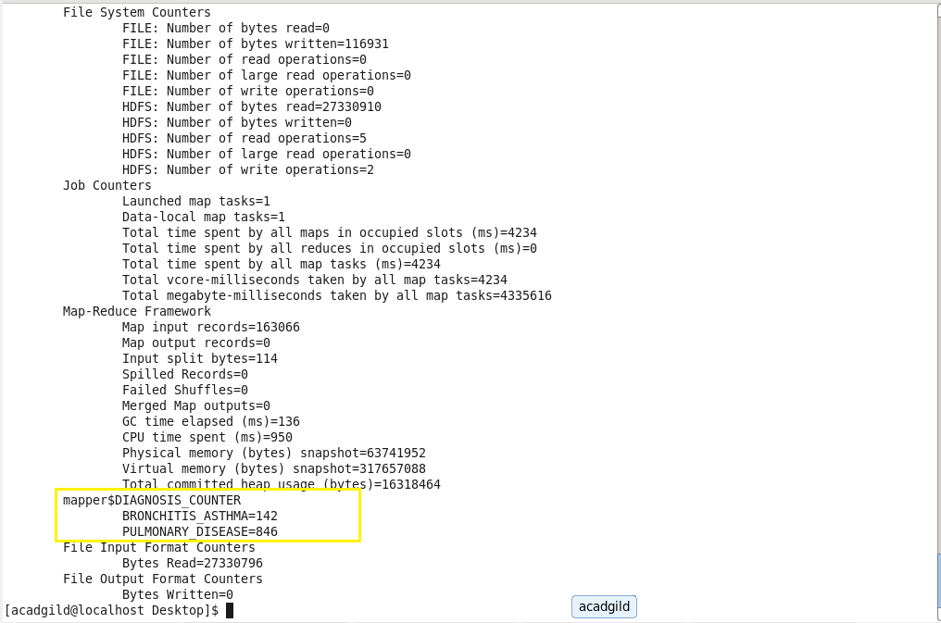

We can see the custom counters in job history as below:

